Implementation of Triple DES (3DES)
Aim
To implement the Triple Data Encryption Standard (3DES) algorithm in C for encrypting and decrypting a given plaintext using three secret keys.

Algorithm
Encryption
- Start.
- Read the plaintext from the user.
- Read three secret keys (Key1, Key2, and Key3).
- Encrypt the plaintext using Key1.
- Decrypt the result using Key2.
- Encrypt the result again using Key3.
- Display the final ciphertext.
- Stop.
Decryption
- Read the ciphertext.
- Decrypt the ciphertext using Key3.
- Encrypt the result using Key2.
- Decrypt the result using Key1.
- Display the original plaintext.
- Stop.
Program:
#include <stdio.h>
#include <string.h>

int main()
{
char plaintext[100], key1[100], key2[100], key3[100];
char stage1[100], stage2[100], ciphertext[100], decrypted[100];
int i, len;
int k1len, k2len, k3len;

printf("Enter Plaintext: ");
scanf("%s", plaintext);

printf("Enter Key1: ");
scanf("%s", key1);

printf("Enter Key2: ");
scanf("%s", key2);

printf("Enter Key3: ");
scanf("%s", key3);

len = strlen(plaintext);
k1len = strlen(key1);
k2len = strlen(key2);
k3len = strlen(key3);

// Step 1: Encrypt with Key1
for(i = 0; i < len; i++)
stage1[i] = plaintext[i] ^ key1[i % k1len];

// Step 2: Decrypt with Key2
for(i = 0; i < len; i++)
stage2[i] = stage1[i] ^ key2[i % k2len];

// Step 3: Encrypt with Key3
for(i = 0; i < len; i++)
ciphertext[i] = stage2[i] ^ key3[i % k3len];

ciphertext[len] = '\0';

printf("\nEncrypted Data (Hex): ");
for(i = 0; i < len; i++)
printf("%02X ", (unsigned char)ciphertext[i]);

// Decryption

// Step 1: Decrypt with Key3
for(i = 0; i < len; i++)
stage2[i] = ciphertext[i] ^ key3[i % k3len];

// Step 2: Encrypt with Key2
for(i = 0; i < len; i++)
stage1[i] = stage2[i] ^ key2[i % k2len];

// Step 3: Decrypt with Key1
for(i = 0; i < len; i++)
decrypted[i] = stage1[i] ^ key1[i % k1len];

decrypted[len] = '\0';

printf("\nDecrypted Text: %s\n", decrypted);

return 0;
}
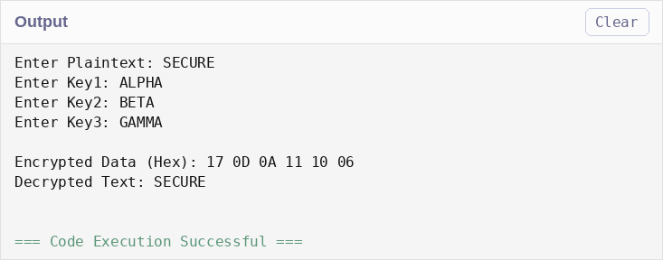
Result
The Triple DES (3DES) encryption and decryption process was implemented successfully in C. The plaintext was encrypted using three keys in the Encrypt–Decrypt–Encrypt (EDE) sequence and then decrypted back to the original message, demonstrating the working principle of the 3DES symmetric-key encryption algorithm.

